**Critical File health status**

The following way we are reading and sending the status.

"**Case A**"

"Divide 5th field by 4th field (used Recs/Total Recs), if the result is more than 85 % it’s a red alert for that store.

There are 24 files being checked against each store. So even if its single file is in issue, raise a red alert with store and file details". (Copied from PPT)

"**Case B**"

While reading the file, if we gets a row has longest chain value greater than 6.So we are ready to send "**amber**" status.

"**Case C**"

We have 24 files for each store.

We are grouping the store and finding the longest chain.

The count of 'longest chain value greater than 6' is greater than 12 for each set of store, we are ready to send "**red**" status.

Otherwise we moves to next set of stores and finds the count of 'longest chain value greater than 6'.

At end of file we sends "**red**" status if “**case A**" OR "**case C**" exists.

At end of file we sends "**amber**" if “**case B**" exists.

Can you please have a look on the screenshots regarding to the dashboard view.

**Red** condition

1. **“ Case A” errors**

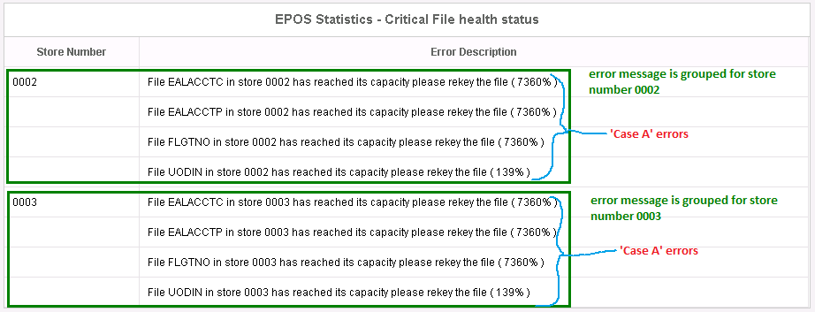

1. **“ Case C” errors**

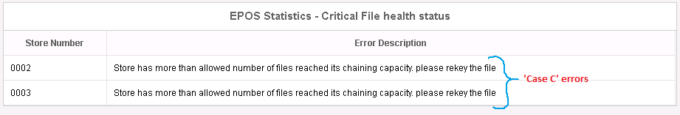

1. **“ Case A” and “Case C” errors**

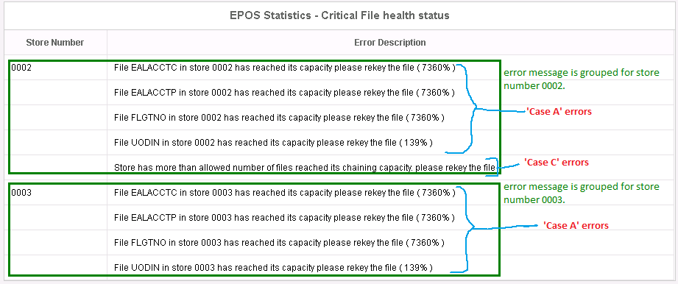

**Amber condition**

1. **“ Case B” errors**

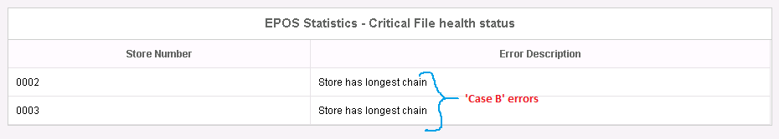

**Success condition**

